Level 0 DFD

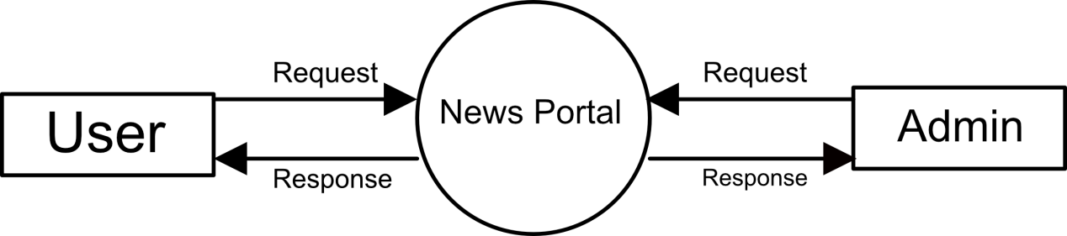

0

Level 1 DFD for User

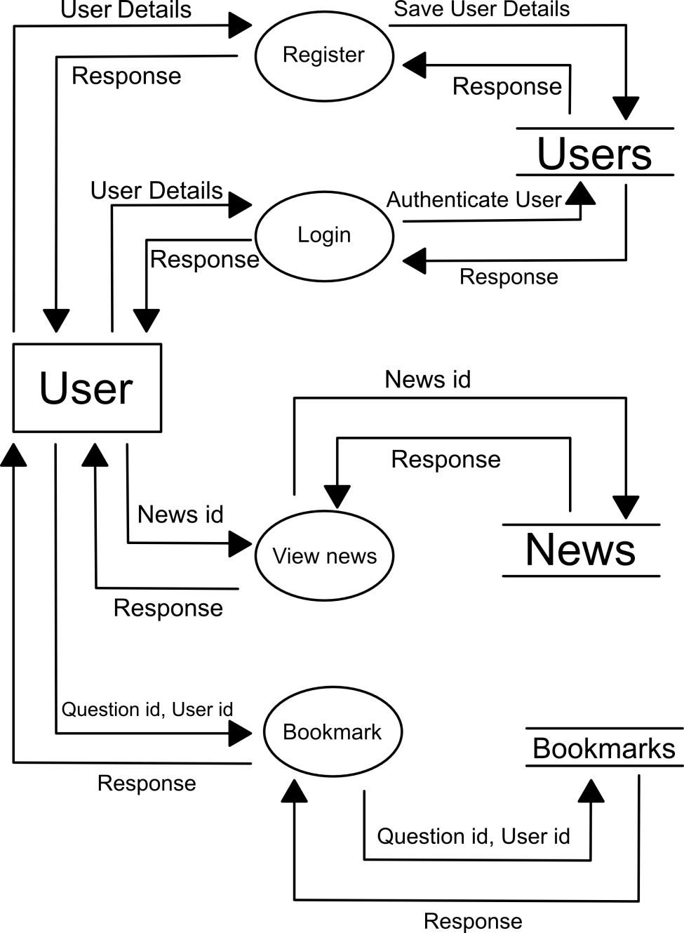

0.1

0.4

0.3

0.2

DFD Level 1 Admin

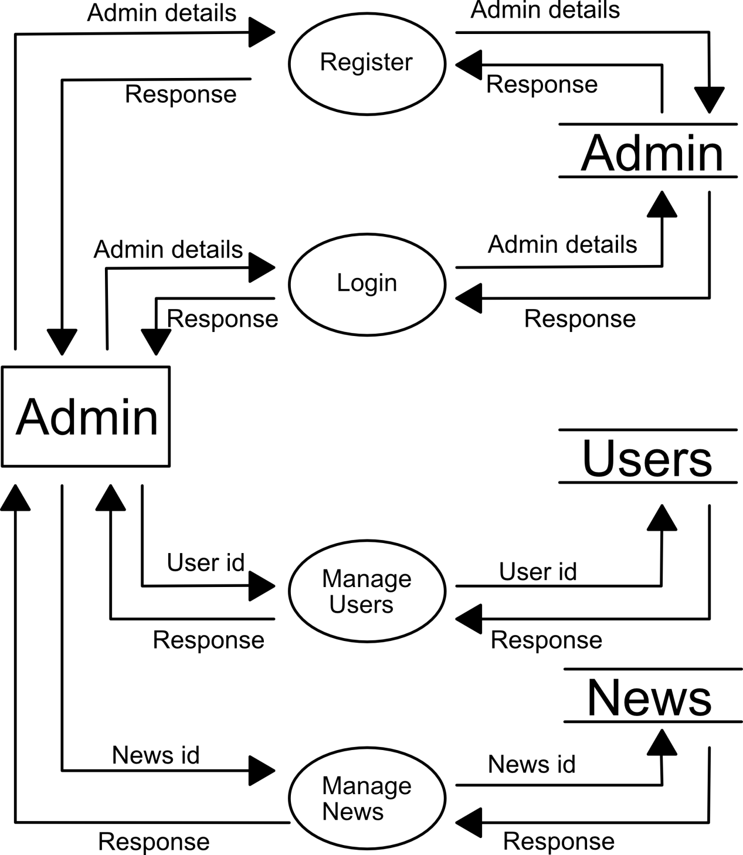

0.8

0.7

0.6

0.5

Data Dictionary

Table: Users

|  |  |  |  |
| --- | --- | --- | --- |
| Field Name | Data Type | Description | Constraint |
| id | number | Unique id of all users | Primary Key |
| Username | varchar | Unique username of user | Not null |
| password | varchar | Alphanumeric password for each user | Not null |
| Fname | varchar | First name of User | Not null |
| Lname | varchar | Last Name of user | Not null |

Table: Admin

|  |  |  |  |
| --- | --- | --- | --- |
| Field Name | Data Type | Description | Constraint |
| id | number | User id of user who is admin | Primary Key |
| Username | varchar | Username used to login | Not null |
| Password | varchar | Password to authenticate login | Not null |

Table: News

|  |  |  |  |
| --- | --- | --- | --- |
| Field Name | Data Type | Description | Constraint |
| id | number | Id of each news | Primary Key |
| Title | varchar | Title of each news | Not null |
| Body | varchar | Main body of news | Not null |
| Date | DateTime | Date news was postedd | Not null |

Table: Bookmarks

|  |  |  |  |
| --- | --- | --- | --- |
| Field Name | Data Type | Description | Constraint |
| id | number | Unique id for each bookmark | Not null |
| User_id | number | User id of user who bookmarked the news | Foreign Key |
| News_id | number | News that was bookmarked | Not null |